EXPERIMENT 7
Medical Reviews Analysis from Social Media Data

1. Aim
To analyze and classify medical/health data by training and comparing machine learning models (K-Nearest Neighbors, Support Vector Machine and Decision Tree) on the heart disease dataset and to identify the best-performing model.

2. Objectives
- To explore a medical dataset using correlation matrix, histograms and class distribution.
- To pre-process the data using one-hot encoding and standard scaling.
- To train K-Nearest Neighbors, Support Vector Machine and Decision Tree classifiers with different hyper-parameters.
- To compare the models by test accuracy and select the best one.

3. Software, Libraries and Dataset
Item | Details
Language / Platform | Python 3, Google Colab
Libraries | NumPy, pandas, Matplotlib, scikit-learn (StandardScaler, train_test_split, KNeighborsClassifier, SVC, DecisionTreeClassifier, RandomForestClassifier)
Dataset | Heart Disease (Cleveland) dataset – heart_cleveland_upload.csv
Size | 297 records, 14 attributes: age, sex, cp, trestbps, chol, fbs, restecg, thalach, exang, oldpeak, slope, ca, thal, target
Target | target (0 = no heart disease: 160 records, 1 = heart disease: 137 records)

4. Procedure / Algorithm
- Import the libraries and load the heart disease dataset.
- Display dataset information and statistical summary.
- Plot the correlation matrix, histograms of all attributes and the count of each target class.
- One-hot encode the categorical attributes and standardise the numerical attributes.
- Split the data into training (67%) and testing (33%) sets.
- Train KNN for K = 1 to 20 and plot the accuracy for each K.
- Train SVC with linear, poly, rbf and sigmoid kernels and plot the accuracies.
- Train Decision Trees with max_features = 1 to the number of columns and plot the accuracies.
- Compare the results and select the best model.

5. Implementation (Code and Output)
Step 1: Import the libraries
Code:
import numpy as np
import pandas as pd
import matplotlib.pyplot as plt
from matplotlib import rcParams
from matplotlib.cm import rainbow
%matplotlib inline
import warnings
warnings.filterwarnings('ignore')

Step 2: Import pre-processing and model-selection tools
Code:
from sklearn.model_selection import train_test_split
from sklearn.preprocessing import StandardScaler

Step 3: Import the classifiers
Code:
from sklearn.neighbors import KNeighborsClassifier
from sklearn.svm import SVC
from sklearn.tree import DecisionTreeClassifier
from sklearn.ensemble import RandomForestClassifier

Step 4: Load the dataset
Code:
dataset = pd.read_csv('heart_cleveland_upload.csv')

Step 5: Dataset information (data types and non-null counts)
Code:
dataset.info()
Output:
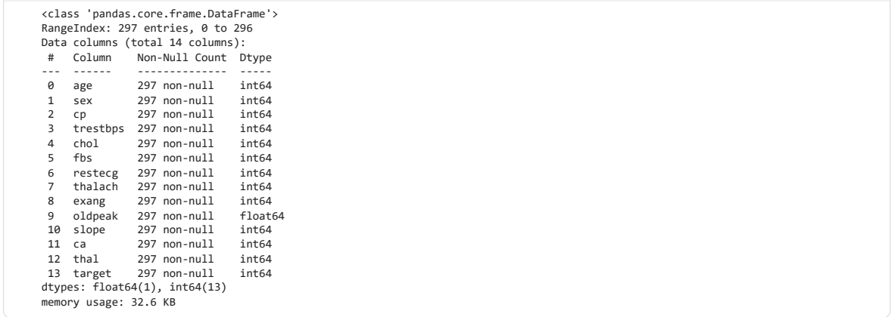

Step 6: Statistical summary of the dataset
Code:
dataset.describe()
Output:
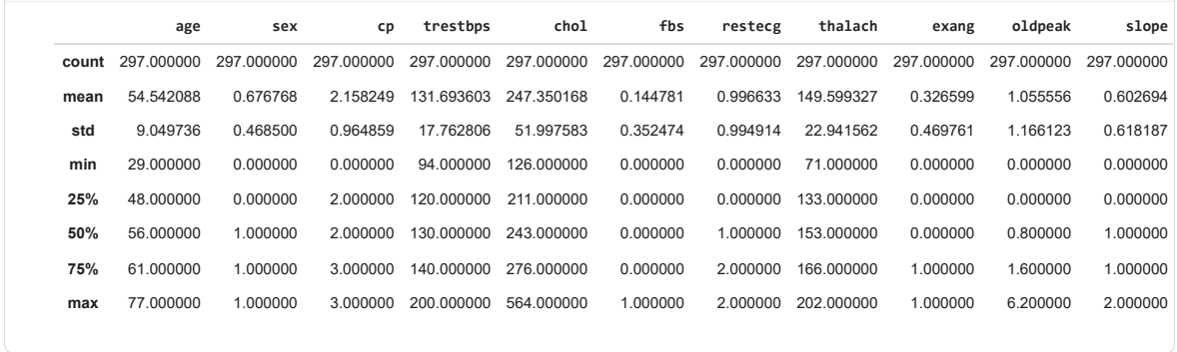

Step 7: Correlation matrix of the attributes
Code:
rcParams['figure.figsize'] = 20, 14
plt.matshow(dataset.corr())
plt.yticks(np.arange(dataset.shape[1]), dataset.columns)
plt.xticks(np.arange(dataset.shape[1]), dataset.columns)
plt.colorbar()
Output:
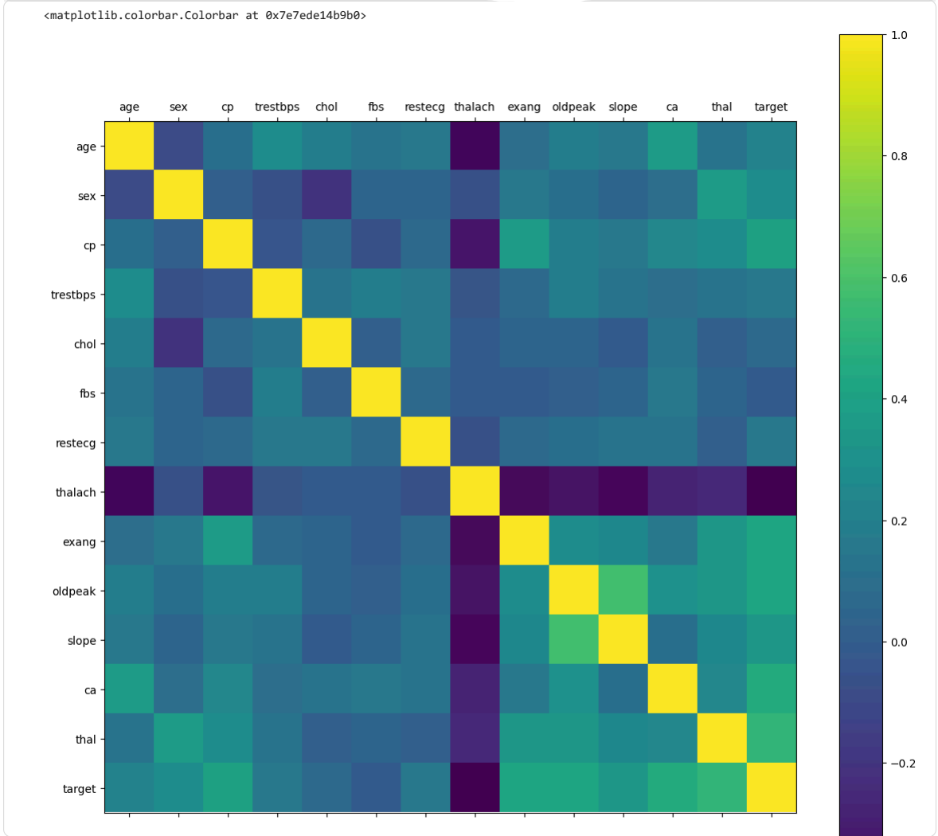

Step 8: Histograms of all attributes
Code:
dataset.hist()
Output:
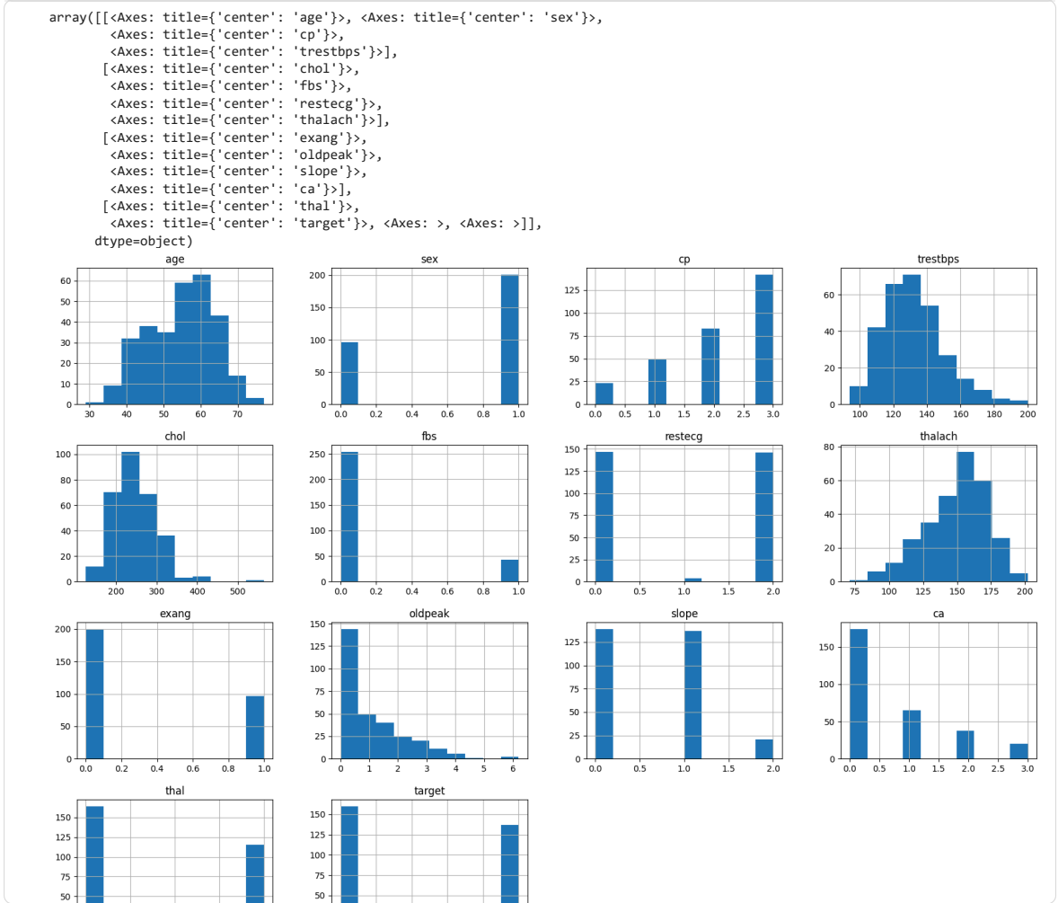

Step 9: Count of each target class
Code:
rcParams['figure.figsize'] = 8,6
plt.bar(dataset['target'].unique(), dataset['target'].value_counts(), color = ['red', 'green'])
plt.xticks([0, 1])
plt.xlabel('Target Classes')
plt.ylabel('Count')
plt.title('Count of each Target Class')
Output:
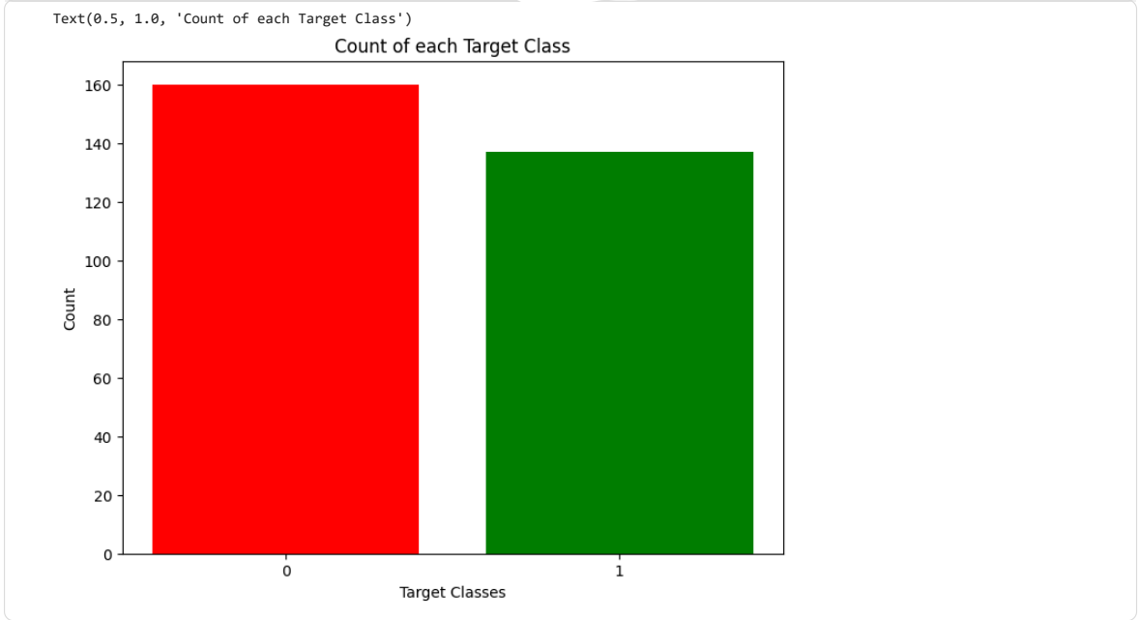

Step 10: One-hot encode the categorical attributes
Code:
dataset = pd.get_dummies(dataset, columns = ['sex', 'cp', 'fbs', 'restecg', 'exang', 'slope', 'ca', 'thal'])

Step 11: Standardise the numerical attributes
Code:
standardScaler = StandardScaler()
columns_to_scale = ['age', 'trestbps', 'chol', 'thalach', 'oldpeak']
dataset[columns_to_scale] = standardScaler.fit_transform(dataset[columns_to_scale])

Step 12: Separate features/target and split into training and testing sets
Code:
y = dataset['target']
X = dataset.drop(['target'], axis = 1)
X_train, X_test, y_train, y_test = train_test_split(X, y, test_size = 0.33, random_state = 0)

Step 13: K-Nearest Neighbors: accuracy for K = 1 to 20
Code:
knn_scores = []
for k in range(1,21):
knn_classifier = KNeighborsClassifier(n_neighbors = k)
knn_classifier.fit(X_train, y_train)
knn_scores.append(knn_classifier.score(X_test, y_test))

Step 14: Plot the KNN scores for different values of K
Code:
plt.plot([k for k in range(1, 21)], knn_scores, color = 'red')
for i in range(1,21):
plt.text(i, knn_scores[i-1], (i, knn_scores[i-1]))
plt.xticks([i for i in range(1, 21)])
plt.xlabel('Number of Neighbors (K)')
plt.ylabel('Scores')
plt.title('K Neighbors Classifier scores for different K values')
Output:
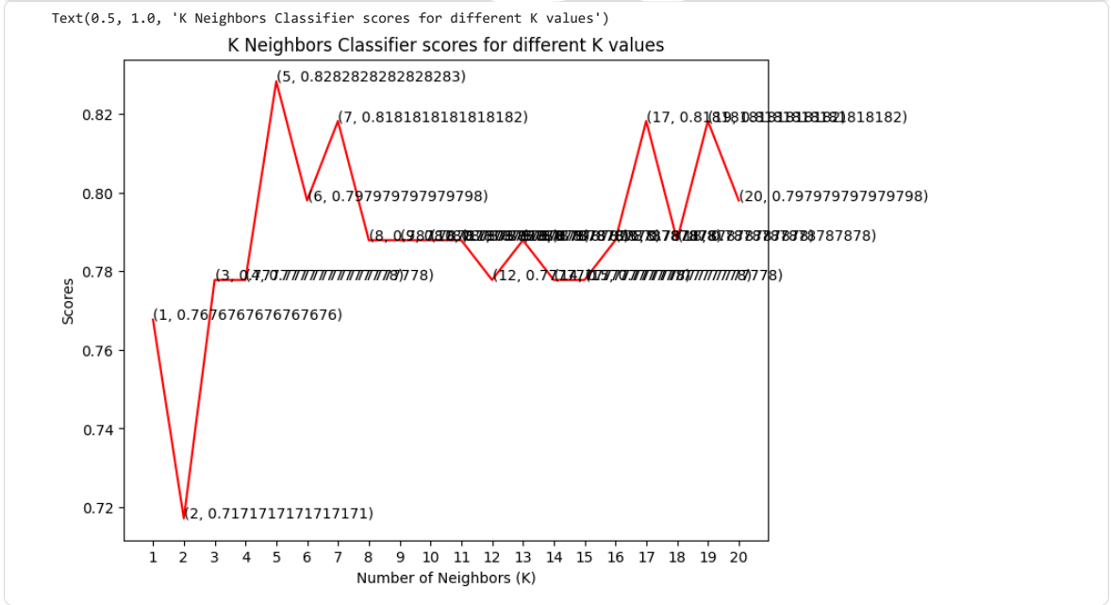

Step 15: Accuracy of the KNN classifier
Code:
print("The score for K Neighbors Classifier is {}% with {} nieghbors.".format(knn_scores[7]*100, 8))
Output:

Step 16: Support Vector Classifier: accuracy for different kernels
Code:
svc_scores = []
kernels = ['linear', 'poly', 'rbf', 'sigmoid']
for i in range(len(kernels)):
svc_classifier = SVC(kernel = kernels[i])
svc_classifier.fit(X_train, y_train)
svc_scores.append(svc_classifier.score(X_test, y_test))

Step 17: Plot the SVC scores for different kernels
Code:
colors = rainbow(np.linspace(0, 1, len(kernels)))
plt.bar(kernels, svc_scores, color = colors)
for i in range(len(kernels)):
plt.text(i, svc_scores[i], svc_scores[i])
plt.xlabel('Kernels')
plt.ylabel('Scores')
plt.title('Support Vector Classifier scores for different kernels')
Output:
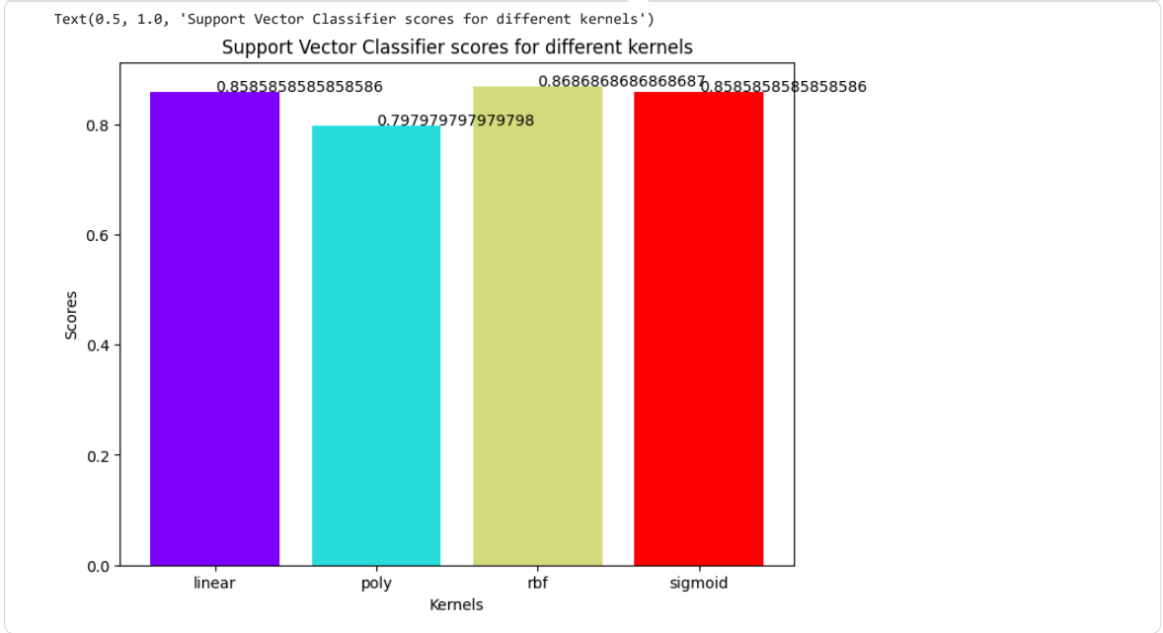

Step 18: Accuracy of the Support Vector Classifier
Code:
print("The score for Support Vector Classifier is {}% with {} kernel.".format(svc_scores[0]*100, 'linear'))
Output:

Step 19: Decision Tree: accuracy for different maximum number of features
Code:
dt_scores = []
for i in range(1, len(X.columns) + 1):
dt_classifier = DecisionTreeClassifier(max_features = i, random_state = 0)
dt_classifier.fit(X_train, y_train)
dt_scores.append(dt_classifier.score(X_test, y_test))

Step 20: Plot the Decision Tree scores for different maximum features
Code:
plt.plot([i for i in range(1, len(X.columns) + 1)], dt_scores, color = 'green')
for i in range(1, len(X.columns) + 1):
plt.text(i, dt_scores[i-1], (i, dt_scores[i-1]))
plt.xticks([i for i in range(1, len(X.columns) + 1)])
plt.xlabel('Max features')
plt.ylabel('Scores')
plt.title('Decision Tree Classifier scores for different number of maximum features')
Output:
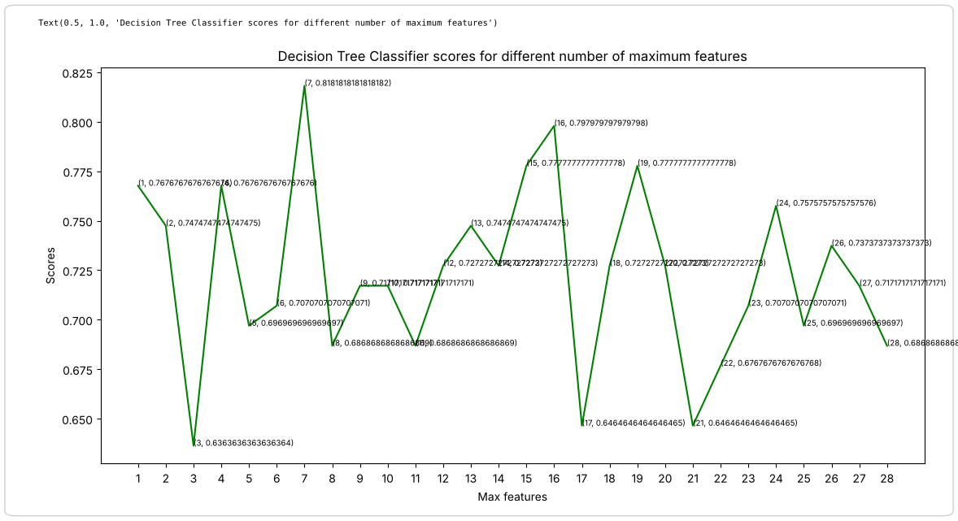

Step 21: Accuracy of the Decision Tree classifier
Code:
print("The score for Decision Tree Classifier is {}% with {} maximum features.".format(dt_scores[17]*100, [2,4,18]))
Output:

6. Observations and Result
- The dataset has 297 records and no missing values. The two classes are fairly balanced (160 without and 137 with heart disease). The correlation matrix shows that cp, exang, oldpeak, ca and thal have the strongest positive relation with the target, while thalach (maximum heart rate) has a negative relation.
- KNN: the best accuracy is 82.83% at K = 5; the lowest is 71.72% at K = 2. At K = 8 (the value printed by the notebook) the accuracy is 78.79%.
- SVC: linear 85.86%, polynomial 79.80%, RBF 86.87% and sigmoid 85.86%. The RBF kernel is the best; the notebook's final print statement reports the linear kernel (85.86%).
- Decision Tree: the accuracy changes with max_features and its highest visible value is 81.82% (at 7 features).
- Comparison: SVC with the RBF kernel (86.87%) > KNN with K = 5 (82.83%) > Decision Tree (about 81.8%). SVM is therefore the most suitable of the three models for this dataset.

7. Conclusion
K-Nearest Neighbors, Support Vector Machine and Decision Tree classifiers were trained and compared on the heart disease dataset. The SVM with an RBF kernel gave the best accuracy (86.87%), followed by KNN (82.83% at K = 5) and the Decision Tree (about 81.8%), showing the importance of hyper-parameter tuning and model comparison in medical data classification.

